Update! Boiler up!

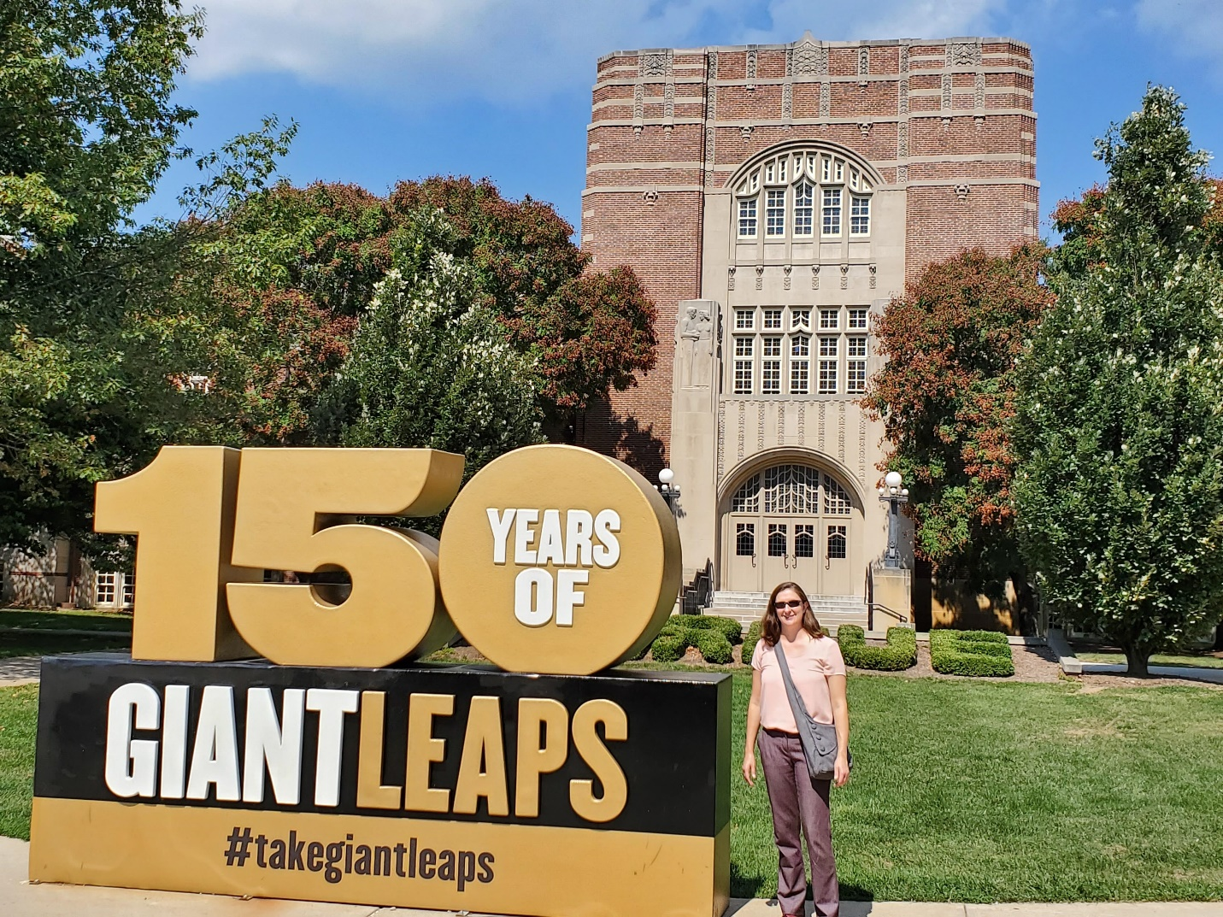

Purdue is celebrating its 150th birthday this year. Photo credit to [Brady Brewer](https://twitter.com/bradybrewer)

Many of you have already heard the news; my family and I moved to West Lafayette IN this summer. I’m now in the Agricultural Economics department at Purdue as Associate Professor and Clearing Corporation Chair of Food and Agricultural Marketing. Today marks one month on the job, in fact, and am so excited to be here!

I’m looking forward to new research, new colleagues, and new friends!

I’m already missing old friends and colleagues at Illinois, though. I had 10 great years there and I can’t imagine a better place to start a career.